**Implement clustering techniques – Hierarchical and K-Means**

**AIM:**

To Implement clustering techniques Hierarchical and K-Means using R programming in R Studio.

**a) HIERARCHIAL CLUSTERING**

# Load the iris dataset data(iris)

# Use only the numeric columns for clustering (exclude the Species column) iris_data <- iris[, -5]

# Standardize the data iris_scaled

<- scale(iris_data)

# Compute the distance matrix distance_matrix <- dist(iris_scaled, method = "euclidean")

# Perform hierarchical clustering using the "complete" linkage method hc_complete <- hclust(distance_matrix, method = "complete")

# Plot the dendrogram plot(hc_complete, main = "Hierarchical Clustering Dendrogram", xlab

= "", sub = "", cex =

0.6)

# Cut the tree to form 3 clusters clusters <- cutree(hc_complete, k = 3)

# Print the cluster memberships print(clusters)

# Add the clusters to the original dataset iris$Cluster

<- as.factor(clusters)

# Display the first few rows of the updated dataset head(iris)

**OUTPUT:**

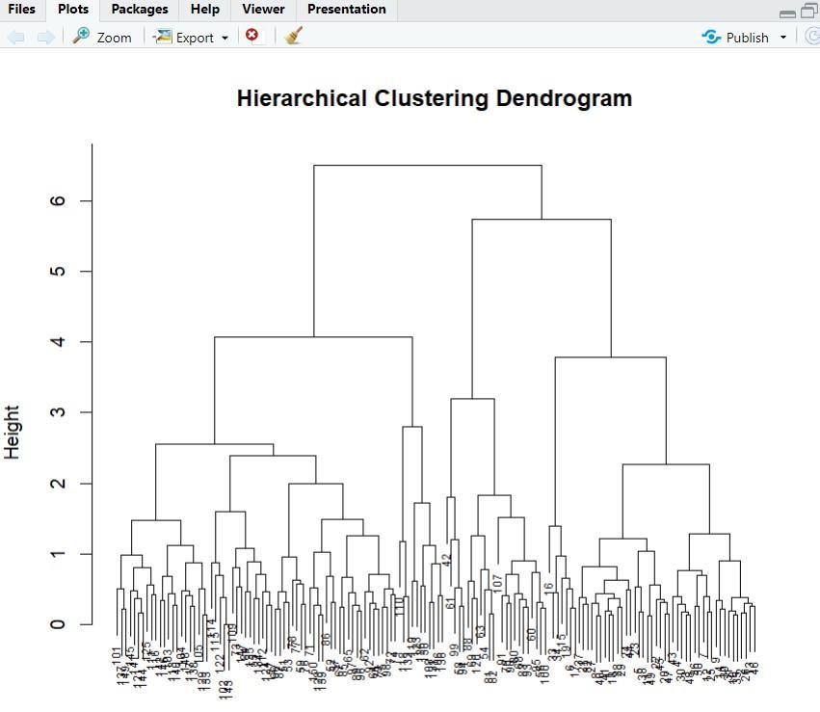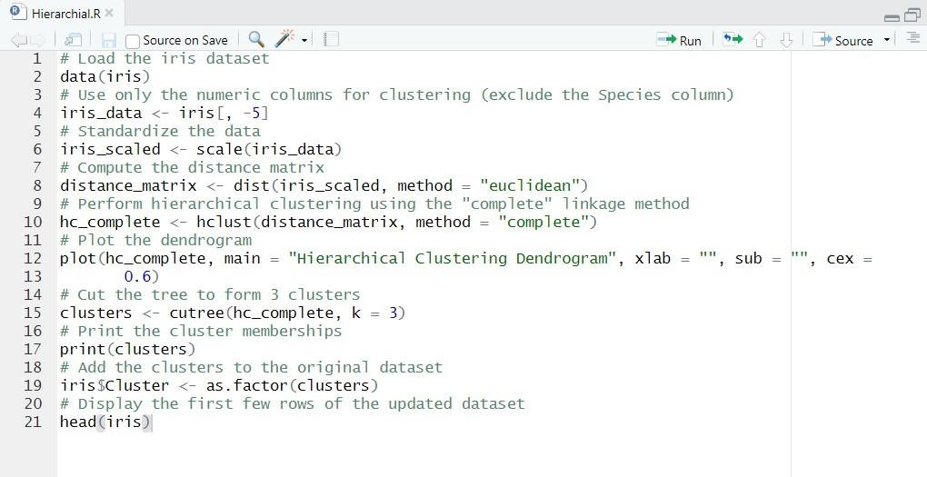

**b) K-MEANS CLUSTERING**

# Load the iris dataset data(iris)

# Use only the numeric columns for clustering (exclude the Species column) iris_data <- iris[, -5]

# Standardize the data iris_scaled <- scale(iris_data)

# Set the number of clusters set.seed(123)

# For reproducibility k <- 3

# Number of clusters

# Perform K-Means clustering

kmeans_result <- kmeans(iris_scaled, centers = k, nstart = 25)

# Print the K-Means result

print(kmeans_result)

# Print the cluster centers

print(kmeans_result$centers)

# Add the cluster assignments to the original dataset iris$Cluster <- as.factor(kmeans_result$cluster)

# Display the first few rows of the updated dataset head(iris)

# Plot the clusters library(ggplot2) ggplot(iris, aes(x = Sepal.Length, y = Sepal.Width, color = Cluster)) + geom_point(size = 3) + labs(title = "K-Means Clustering of Iris Dataset", x = "Sepal Length", y = "Sepal Width") **OUTPUT:**

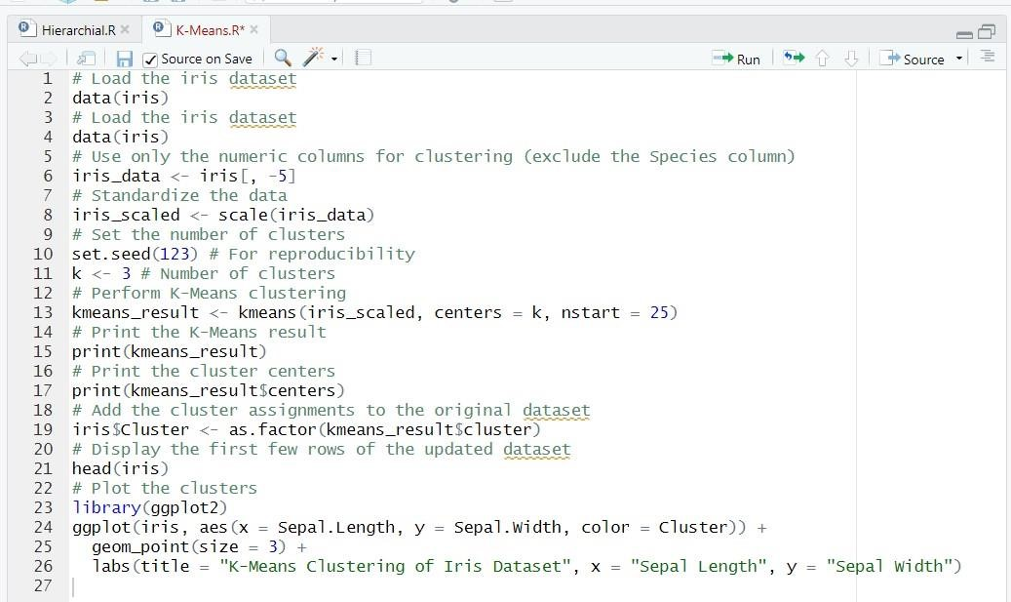

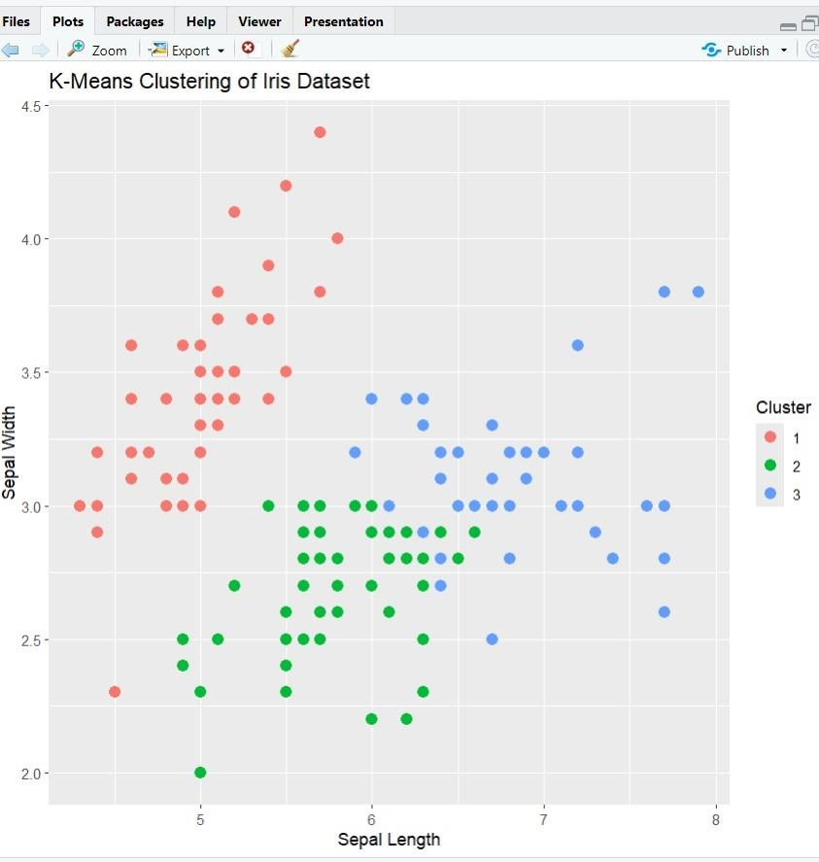

**RESULT:**

Thus, the Implement clustering techniques Hierarchical and K-Means using R programming in R Studio have been successfully executed.